USER ACCEPTANCE TESTING

|  |  |
| --- | --- |
| Date | 19 November 2022 |
| Team ID | PNT2022TMID22872 |
| Project name | Real –time river water quality monitoring and control system |

UAT REPORT

UAT EXECUTION

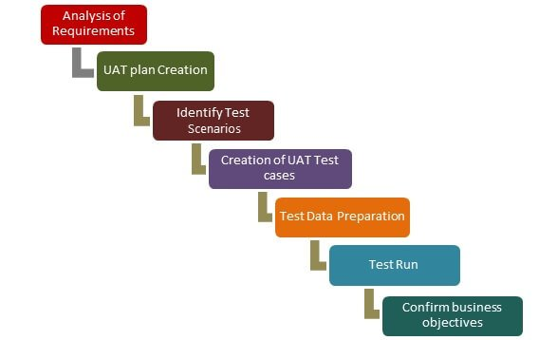

With your UAT process clearly defined, you can now begin testing, address any defects and decide if you should move ahead to production or not. To make this step optimally efficient, you’ll need flawless communication and balance between testers and developers, focusing on documentation (see below for a deeper dive into this issue), progress reporting, and defect management.

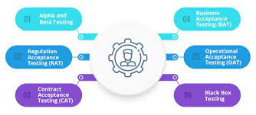

Execution: Remove Idle Time and Relieve Bottlenecks

UAT workflows often feel like running a relay race blindfolded to your key users. There are so many dependencies they are simply unaware of as they wait their turn in a waterfall-type workflow. This is anything but agile UAT. Instead, you can relieve dependency bottlenecks with embedded workflow automation features – even in a multi-step, multi-tester business process. Notifications, for example, can let a user know when it’s their turn to test within the business process (a ‘Time to Test’ alert) or when a defect is resolved and ready for retesting (a ‘Retest’ notification), and a ‘Close’ notification informs developers of test or retest success.

UTILIZATION OF TEST CASES

